**Warehouse creation:**

**In Web UI**

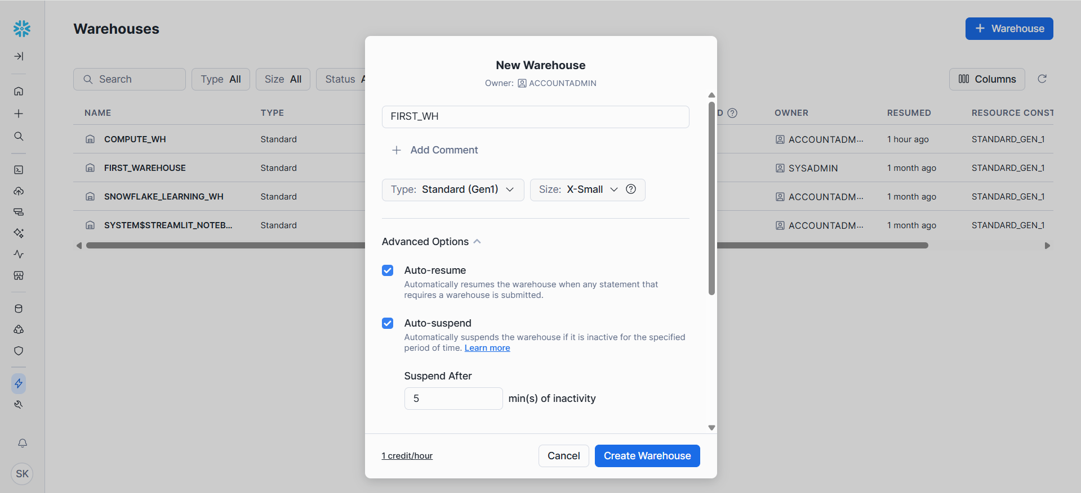

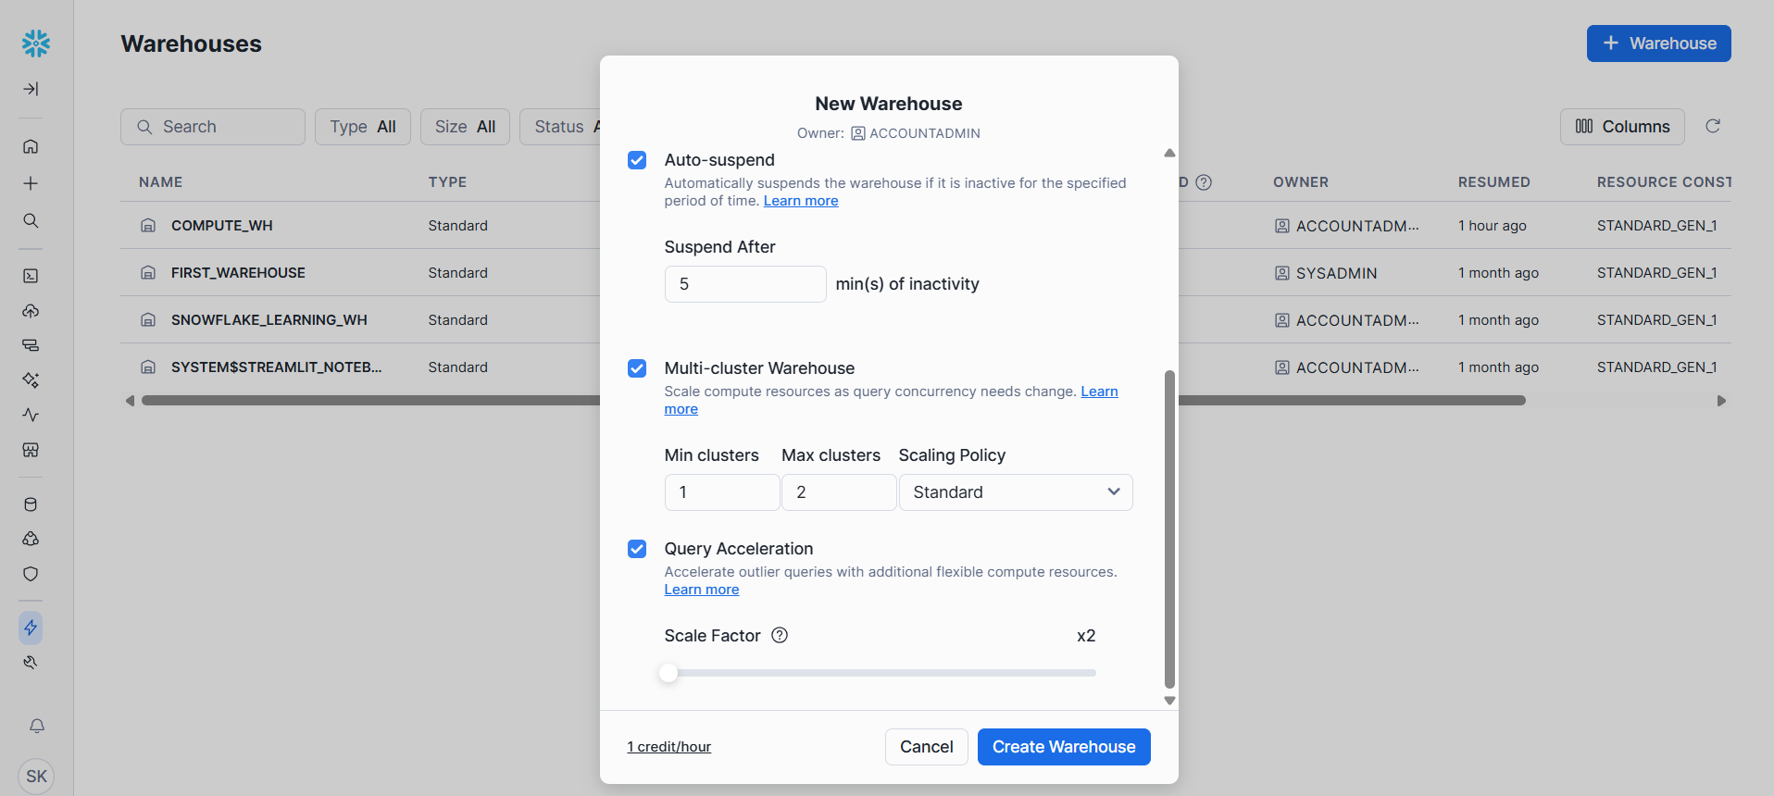

**Using Snowsight**

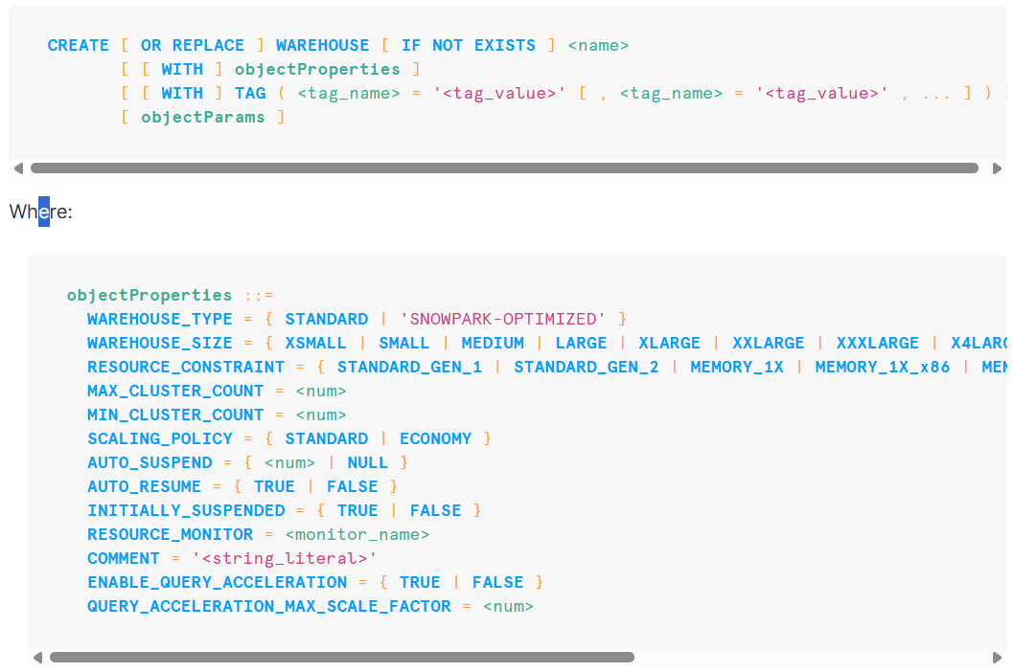

**Example:**

**CREATE OR REPLACE WAREHOUSE SAI_WH**

**WITH**

**WAREHOUSE_SIZE = XSMALL**

**MIN_CLUSTER_COUNT = 1**

**MAX_CLUSTER_COUNT = 3**

**SCALING_POLICY = STANDARD**

**AUTO_SUSPEND = 300 --5 MINIUTES**

**INITIALLY_SUSPENDED = TRUE**

**COMMENT = 'This is our first warehouse';**

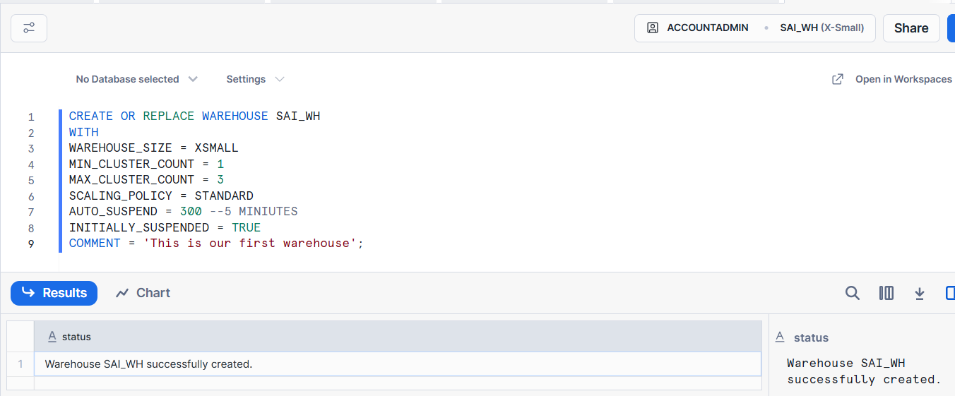

**Data Types:**

| Data Type | Description | Example |
| --- | --- | --- |
| NUMBER / DECIMAL / NUMERIC | Fixed-point decimal numbers (can specify precision and scale). | NUMBER(10,2) → 12345.67 |
| INT / INTEGER / BIGINT / SMALLINT / TINYINT / BYTEINT | Integer numbers (all are stored as NUMBER). | 100 |
| FLOAT / FLOAT4 / FLOAT8 / DOUBLE / DOUBLE PRECISION / REAL | Floating-point numbers. | 123.4567 |
| VARCHAR / CHAR / CHARACTER / STRING / TEXT | Variable-length string. Default length is unlimited. | 'Hello' |
| CHAR / CHARACTER | Fixed-length string (padded with spaces). | 'A ' |
| BINARY / VARBINARY | Binary strings (used for files, encrypted values, etc.). | 0xDEADBEEF |
| DATE | Stores calendar date (no time). | 2025-10-14 |
| TIME | Stores time of day (no date). | 12:30:45 |
| TIMESTAMP | Alias for TIMESTAMP_NTZ. | 2025-10-14 12:30:45 |
| TIMESTAMP_NTZ | Timestamp without time zone. | 2025-10-14 12:30:45 |
| TIMESTAMP_LTZ | Timestamp with local time zone. | 2025-10-14 12:30:45 |
| TIMESTAMP_TZ | Timestamp with explicit time zone. | 2025-10-14 12:30:45 +05:30 |
| BOOLEAN | True/False values | TRUE, FALSE |
| VARIANT | Can store JSON, Avro, ORC, Parquet, XML, etc. | {'name': 'Sai', 'age': 30} |
| OBJECT | Key-value pairs (similar to JSON objects). | {'a':1, 'b':2} |
| ARRAY | Ordered list of elements. | [1,2,3,4] |
| GEOGRAPHY | Stores geospatial data in WGS 84 standard. | 'POINT(-122.35 37.55)' |

**Stages:**

In Snowflake, stages are locations where data files are stored before being loaded into tables or after being unloaded from tables.  
They act as intermediate storage areas for data ingestion and extraction.

| **Feature / Property** | **User Stage** | **Table Stage** | **Named Stage** |
| --- | --- | --- | --- |
| 🏗 **Creation** | Automatically created for each user | Automatically created for each table | Manually created by user |
| 👥 **Scope / Ownership** | Specific to each user | Specific to a single table | Shared — can be used by multiple users/tables |
| 🗂 **Usage Purpose** | Temporary, personal file staging | Staging files linked to one table | Centralized or external data staging |
| 📦 **File Location** | Internal only (Snowflake-managed) | Internal only (Snowflake-managed) | Internal or external (e.g., S3, Azure, GCS) |
| 🔐 **Access Control** | Only the owner (user) can access | Only table owner / granted roles | Full RBAC (can grant privileges) |
| 🧭 **Reference Syntax** | @~ | @%table_name | @stage_name |
| ⬆️ **PUT/GET Support** | Yes | Yes | Yes (internal), not needed for external |
| 🧾 **File Persistence** | Temporary | Temporary | Persistent (managed manually) |
| 🌐 **Integration with External Storage** | ❌ No | ❌ No | ✅ Yes |
| 💡 **Typical Use Case** | Testing, quick uploads | One-table loading | Production pipelines, shared data, external data |

**Steps to create stage:**

//first create database

CREATE OR REPLACE DATABASE FIRST_DB;

//use the database

USE DATABASE FIRST_DB;

//create stage schema to store stages

CREATE OR REPLACE SCHEMA external_stages;

// creating stage object from publicly available s3 bucket

CREATE OR REPLACE STAGE FIRST_DB.external_stages.aws_stage

url='s3://bucketsnowflakes3';

// List files in stage

LIST @FIRST_DB.EXTERNAL_STAGES.aws_stage;

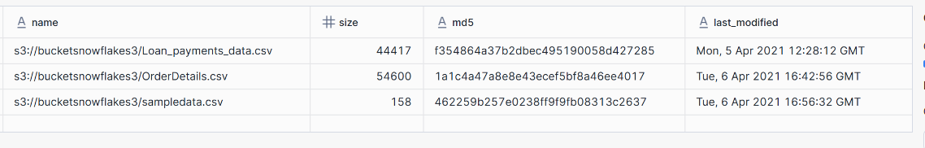

// Creating ORDERS table to load data from staging area

CREATE OR REPLACE TABLE FIRST_DB.PUBLIC.ORDERS (

ORDER_ID VARCHAR(30),

AMOUNT INT,

PROFIT INT,

QUANTITY INT,

CATEGORY VARCHAR(30),

SUBCATEGORY VARCHAR(30));

// Copy command with pattern for file names

COPY INTO FIRST_DB.PUBLIC.ORDERS

FROM @FIRST_DB.external_stages.aws_stage

file_format= (type = csv field_delimiter=',' skip_header=1)

pattern='.*Order.*';



**Example to load only specific columns:**

//creating table

CREATE OR REPLACE TABLE FIRST_DB.PUBLIC.ORDERS_EX (

ORDER_ID VARCHAR(30),

AMOUNT INT

);

//copy command to load only first 2 columns

COPY INTO FIRST_DB.PUBLIC.ORDERS_EX

FROM (select s.$1, s.$2 from @FIRST_DB.external_stages.aws_stage s)

file_format= (type = csv field_delimiter=',' skip_header=1)

files=('OrderDetails.csv');

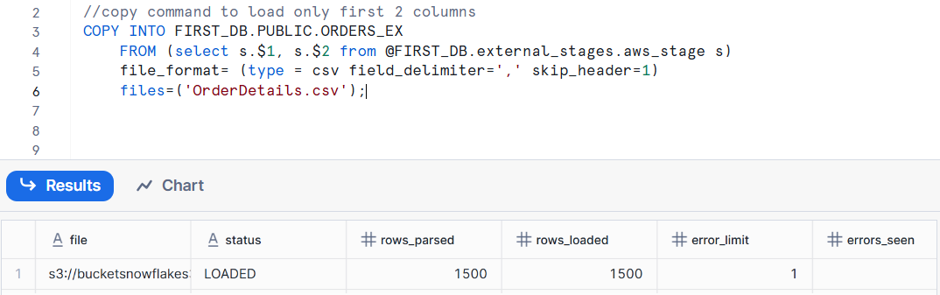

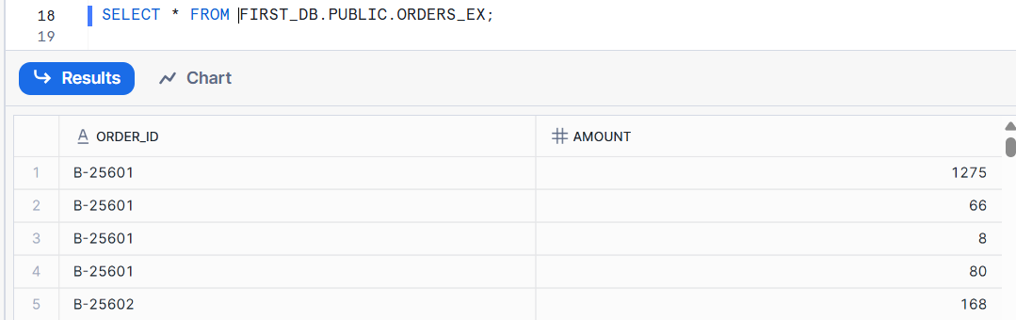

**Example 2 to load only specific columns:**

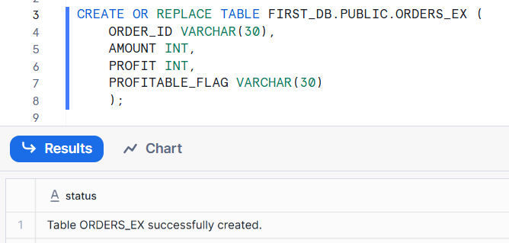

COPY INTO FIRST_DB.PUBLIC.ORDERS_EX (ORDER_ID,PROFIT)

FROM (select

s.$1,

s.$3

from @FIRST_DB.external_stages.aws_stage s)

file_format= (type = csv field_delimiter=',' skip_header=1)

files=('OrderDetails.csv');

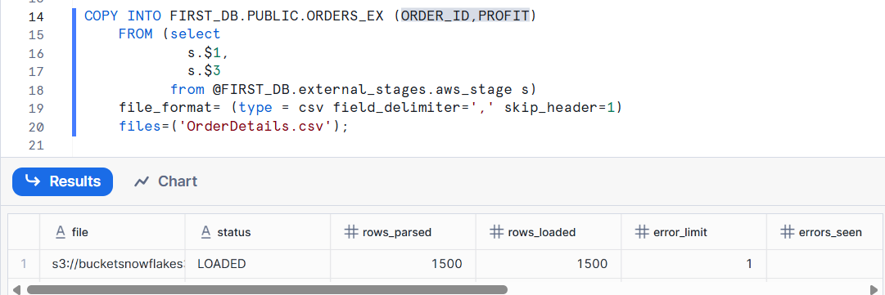

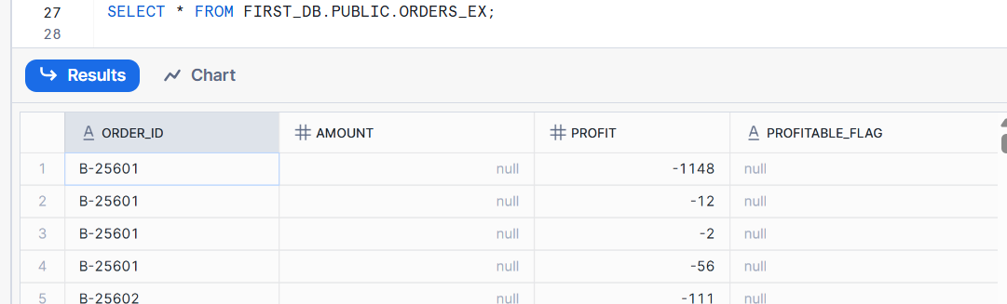

**Copy Command: ON_ERROR options**

| Option | Behavior | When to Use |
| --- | --- | --- |
| ABORT_STATEMENT *(default)* | Stops the entire load if any error occurs. | When you want strict data quality. |
| CONTINUE | Loads valid records and skips the bad ones. | When you can tolerate some bad records. |
| SKIP_FILE | Skips the entire file if any error occurs in that file. | When you want to skip problematic files entirely. |
| SKIP_FILE_<n> | Skips the file if the number of errors in that file exceeds n. | When some errors are okay, but not too many. |
| SKIP_FILE_<n>_PERCENT | Skips the file if the error rate exceeds n%. | Useful for large files where a few errors are acceptable. |

**Example : CONTINUE**

**// Create new stage**

CREATE OR REPLACE STAGE FIRST_DB.external_stages.aws_stage_errorex

url='s3://bucketsnowflakes4';

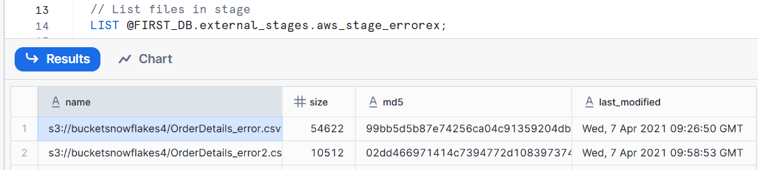

// Create example table

CREATE OR REPLACE TABLE FIRST_DB.PUBLIC.ORDERS_EX (

ORDER_ID VARCHAR(30),

AMOUNT INT,

PROFIT INT,

QUANTITY INT,

CATEGORY VARCHAR(30),

SUBCATEGORY VARCHAR(30));

// Error handling using the ON_ERROR CONTINUE option

COPY INTO FIRST_DB.PUBLIC.ORDERS_EX

FROM @MANAGE_DB.external_stages.aws_stage_errorex

file_format= (type = csv field_delimiter=',' skip_header=1)

files = ('OrderDetails_error.csv')

ON_ERROR = 'CONTINUE';

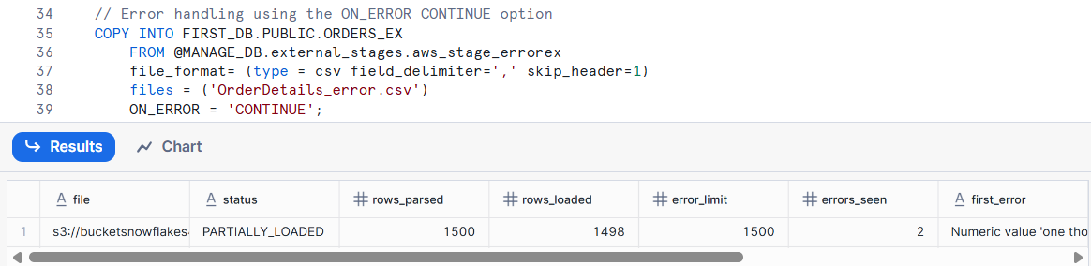

**Example : ABORT_STATEMENT**

COPY INTO FIRST_DB.PUBLIC.ORDERS_EX

FROM @FIRST_DB.external_stages.aws_stage_errorex

file_format= (type = csv field_delimiter=',' skip_header=1)

files = ('OrderDetails_error.csv','OrderDetails_error2.csv')

ON_ERROR = 'ABORT_STATEMENT';

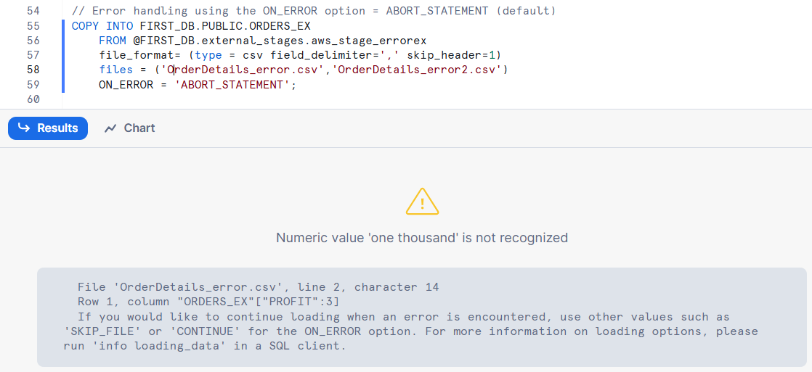

**Example : SKIP_FILE**

// Error handling using the ON_ERROR option = SKIP_FILE

COPY INTO FIRST_DB.PUBLIC.ORDERS_EX

FROM @FIRST_DB.external_stages.aws_stage_errorex

file_format= (type = csv field_delimiter=',' skip_header=1)

files = ('OrderDetails_error.csv','OrderDetails_error2.csv')

ON_ERROR = 'SKIP_FILE';

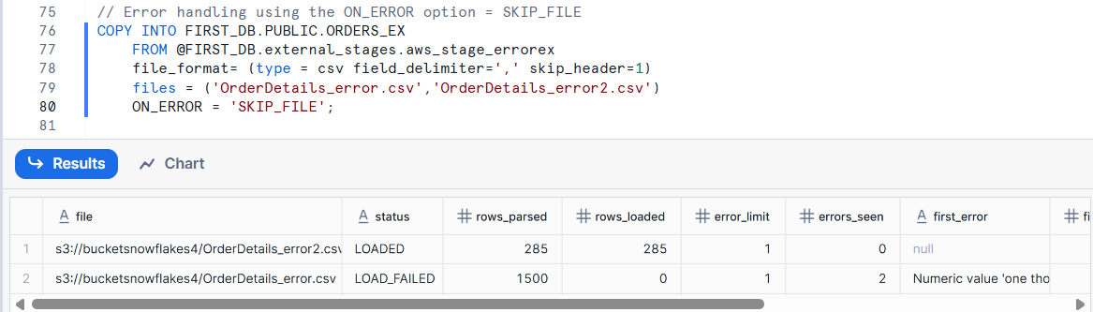

**Example : SKIP_FILE_<number>**

COPY INTO FIRST_DB.PUBLIC.ORDERS_EX

FROM @FIRST_DB.external_stages.aws_stage_errorex

file_format= (type = csv field_delimiter=',' skip_header=1)

files = ('OrderDetails_error.csv','OrderDetails_error2.csv')

ON_ERROR = 'SKIP_FILE_2';

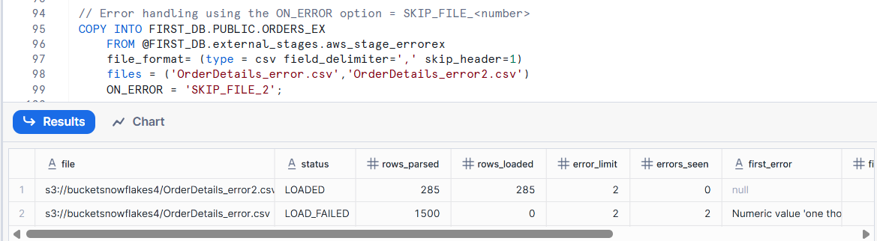

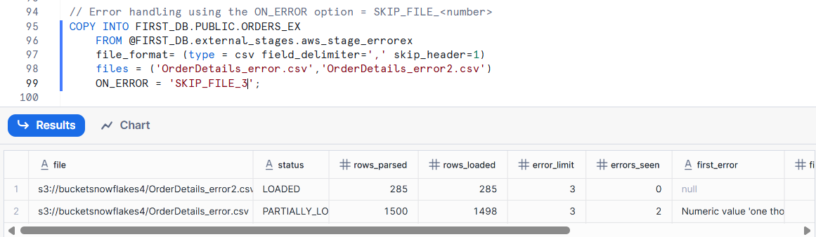

**Example : SKIP_FILE_<number>_PERCENT**

COPY INTO FIRST_DB.PUBLIC.ORDERS_EX

FROM @FIRST_DB.external_stages.aws_stage_errorex

file_format= (type = csv field_delimiter=',' skip_header=1)

files = ('OrderDetails_error.csv','OrderDetails_error2.csv')

ON_ERROR = 'SKIP_FILE_3%';

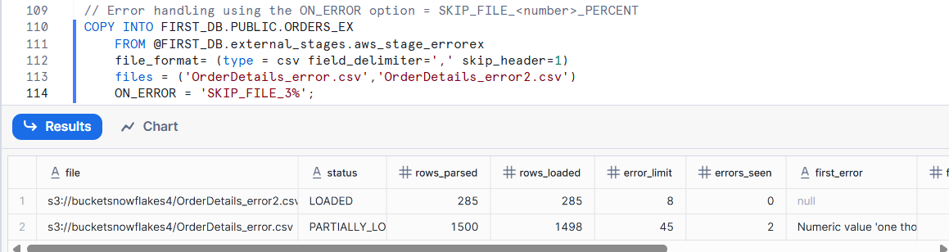

| **Limit Type** | **Limit** | **Best Practice** |
| --- | --- | --- |
| Per compressed file | 5 GB max | Prefer smaller files (100–250 MB) |
| Per uncompressed file | 50 GB max | Split files for speed |
| Per row | 16 MB | Avoid very wide records |
| Total COPY load size | No hard limit | Use parallel load with many files |
| Number of files per COPY | Thousands recommended, not millions | Batch loads if needed |

**File Formats:**

file formats define how data files are structured when you load (COPY INTO) or unload (COPY INTO … FROM) data between stages and tables.

| **File Format** | **Description** | **Typical Extension** |
| --- | --- | --- |
| **CSV** | Comma-separated values; plain text format widely used for tabular data. | .csv / .txt |
| **JSON** | Semi-structured data stored in JavaScript Object Notation format. | .json |
| **Avro** | Row-based binary format ideal for streaming and big data pipelines. | .avro |
| **ORC** | Optimized Row Columnar format, efficient for analytics workloads. | .orc |
| **Parquet** | Columnar format with good compression and performance. | .parquet |
| **XML** | Semi-structured data in Extensible Markup Language format. | .xml |

**Example to load CSV file:**

// Creating schema to keep things organized

CREATE OR REPLACE SCHEMA FIRST_DB.file_formats;

// Creating file format object

CREATE OR REPLACE file format FIRST_DB.file_formats.my_file_format;

// See properties of file format object

DESC file format FIRST_DB.file_formats.my_file_format;

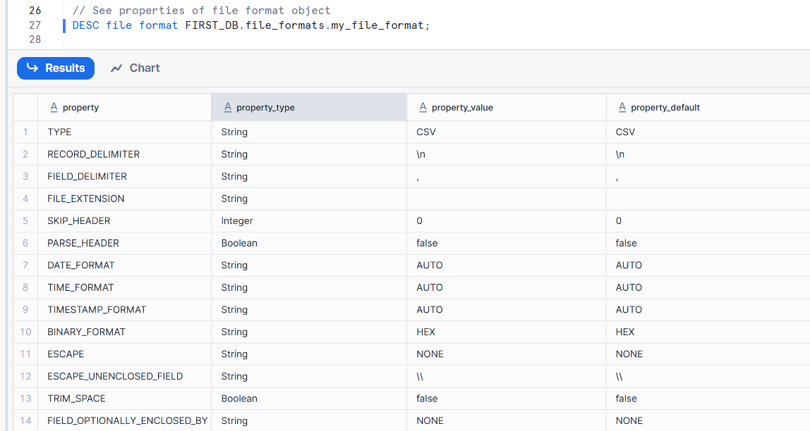

// Creating table

CREATE OR REPLACE TABLE FIRST_DB.PUBLIC.ORDERS_EX (

ORDER_ID VARCHAR(30),

AMOUNT INT,

PROFIT INT,

QUANTITY INT,

CATEGORY VARCHAR(30),

SUBCATEGORY VARCHAR(30));

// Using file format object in Copy command

COPY INTO FIRST_DB.PUBLIC.ORDERS_EX

FROM @FIRST_DB.external_stages.aws_stage_errorex

file_format= (FORMAT_NAME=FIRST_DB.file_formats.my_file_format)

files = ('OrderDetails_error.csv')

ON_ERROR = 'SKIP_FILE_3';

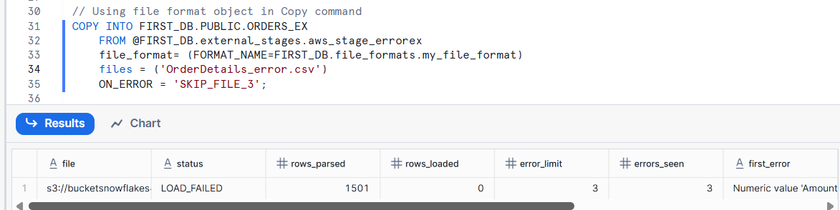**\* Load failed due to snowflake is considering header as first record.**

// Altering file format object to skip the header

ALTER file format FIRST_DB.file_formats.my_file_format

SET SKIP_HEADER = 1;

After changing file format valid records are loaded into table.

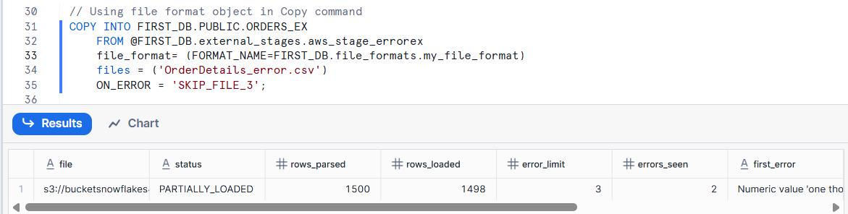

**Note: Altering the type of a file format is not possible instead recreate the file format.**

**VALIDATION_MODE:**

VALIDATION_MODE parameter in the COPY INTO command allows you to validate your data files before actually loading them into a table.

| **Option** | **Description** | **Example Output** |
| --- | --- | --- |
| RETURN_ALL_ERRORS | Returns **all** errors found in the file(s). | Lists all error rows |
| RETURN_ERRORS | Returns up to **1,000 error rows**. | Sample of error rows |
| RETURN_N_ROWS | Returns the **first N rows** from each file. | Quick preview of data |

// Prepare database & table

CREATE OR REPLACE DATABASE COPY_DB;

//creating ordres table

CREATE OR REPLACE TABLE COPY_DB.PUBLIC.ORDERS (

ORDER_ID VARCHAR(30),

AMOUNT VARCHAR(30),

PROFIT INT,

QUANTITY INT,

CATEGORY VARCHAR(30),

SUBCATEGORY VARCHAR(30));

create or replace stage copy_db.public.aws_stage_copy

url ='s3://snowflakebucket-copyoption/returnfailed/';

list @copy_db.public.aws_stage_copy;

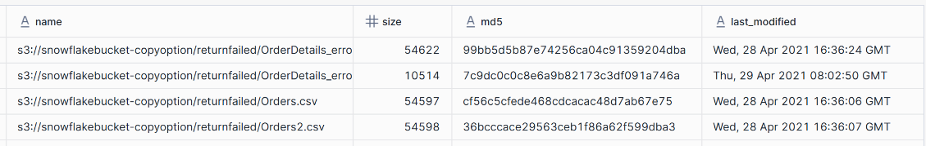

-- show all errors --

copy into copy_db.public.orders

from @copy_db.public.aws_stage_copy

file_format = (type=csv field_delimiter=',' skip_header=1)

pattern='.*Order.*'

validation_mode=return_errors;

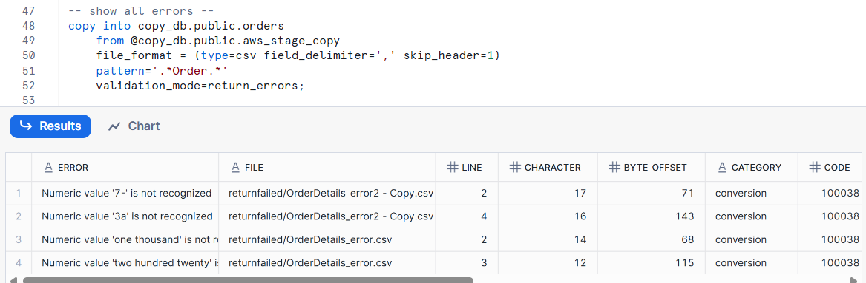

-- validate first n rows --

copy into copy_db.public.orders

from @copy_db.public.aws_stage_copy

file_format = (type=csv field_delimiter=',' skip_header=1)

pattern='.*error.*'

validation_mode=return_1_rows;

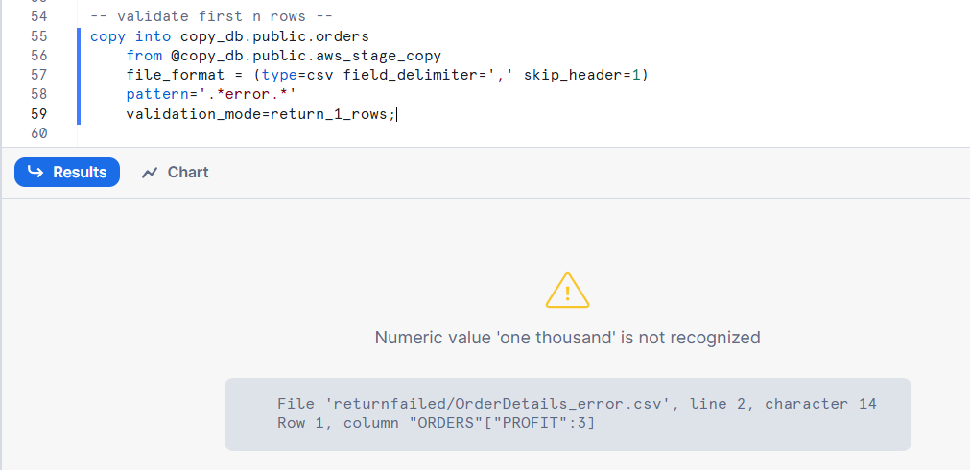

**Working with rejected records:**

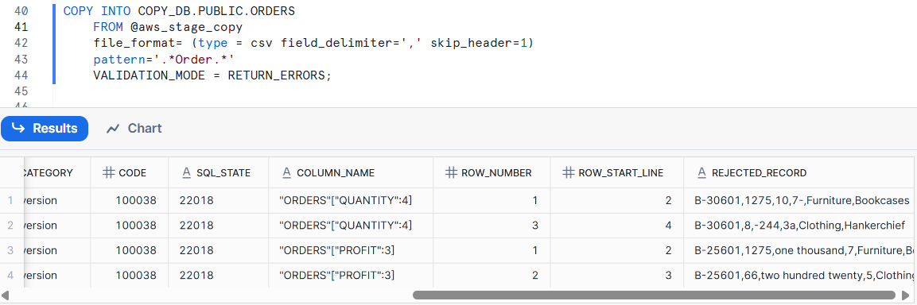

// Storing rejected /failed results in a table

CREATE OR REPLACE TABLE rejected AS

select rejected_record from table(result_scan(last_query_id()));

Load valid records into the actual table.

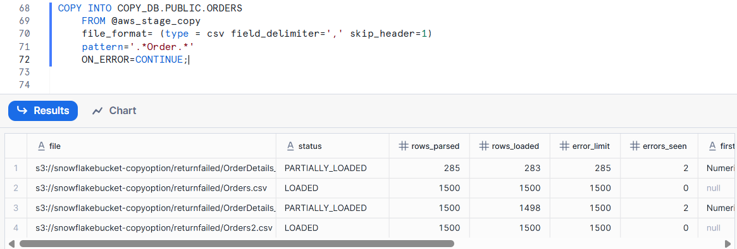

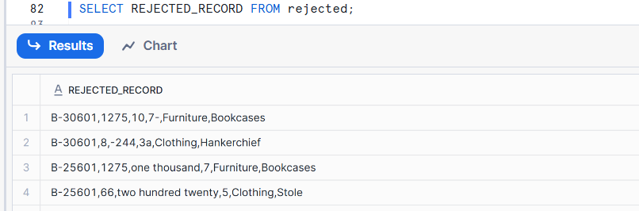

--creating another table with the rejected records

CREATE OR REPLACE TABLE rejected_values as

SELECT

SPLIT_PART(rejected_record,',',1) as ORDER_ID,

SPLIT_PART(rejected_record,',',2) as AMOUNT,

SPLIT_PART(rejected_record,',',3) as PROFIT,

SPLIT_PART(rejected_record,',',4) as QUATNTITY,

SPLIT_PART(rejected_record,',',5) as CATEGORY,

SPLIT_PART(rejected_record,',',6) as SUBCATEGORY

FROM rejected;

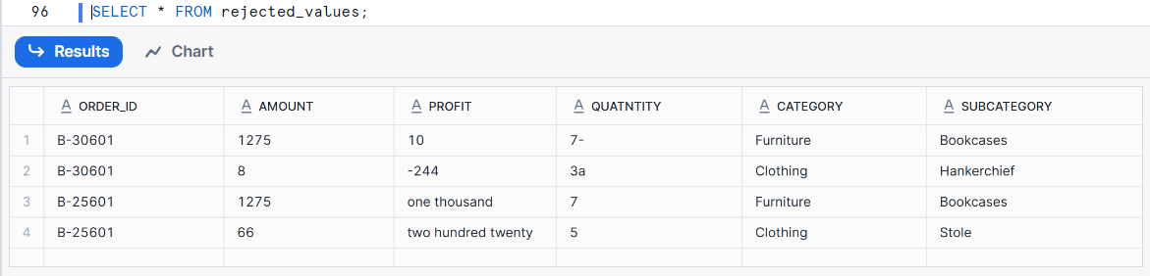

**SIZE_LIMIT:**

SIZE_LIMIT parameter in the COPY INTO command is used to restrict the maximum size (in bytes) of files that are processed during a load.

SIZE_LIMIT = <bytes>

* The SIZE_LIMIT value applies to the entire set of files processed by the COPY statement, not to each individual file.
* Skipped files appear in the COPY_HISTORY and LOAD_HISTORY views.
* A skipped file due to SIZE_LIMIT is **not an error**, but Snowflake reports it in the output.
* Snowflake guarantees loading at least one file even if the total size exceeds SIZE_LIMIT.
* The COPY operation continues processing the file that exceeds the threshold before stopping. For example, if the SIZE_LIMIT is set to 15MB and there are three 10MB files, the process stops after successfully loading two files.

**Example**

// Prepare database & table

CREATE OR REPLACE DATABASE COPY_DB;

CREATE OR REPLACE TABLE COPY_DB.PUBLIC.ORDERS (

ORDER_ID VARCHAR(30),

AMOUNT VARCHAR(30),

PROFIT INT,

QUANTITY INT,

CATEGORY VARCHAR(30),

SUBCATEGORY VARCHAR(30));

// Prepare stage object

CREATE OR REPLACE STAGE COPY_DB.PUBLIC.aws_stage_copy

url='s3://snowflakebucket-copyoption/size/';

// List files in stage

LIST @aws_stage_copy;

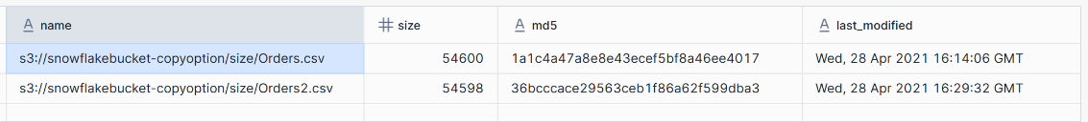

//Load data using copy command

COPY INTO COPY_DB.PUBLIC.ORDERS

FROM @aws_stage_copy

file_format= (type = csv field_delimiter=',' skip_header=1)

pattern='.*Order.*'

SIZE_LIMIT=20000;

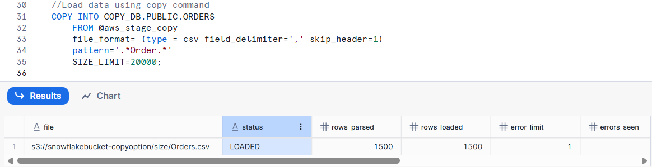

Now increased the size limit to **54600**

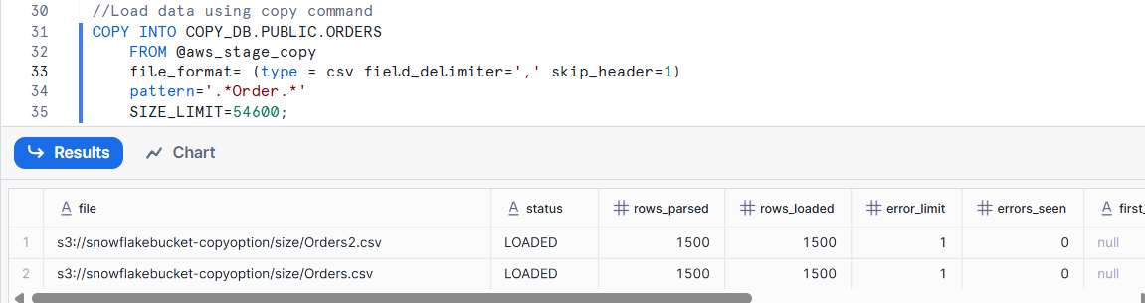

In this example threshold is 54600 and first it loaded the file with 54598 and threshold is not exceeded so it loaded the second file.

**RETURN_FAILED_ONLY**

Specifies whether to return only files that have failed to load in the statement result.

//created a table

CREATE OR REPLACE TABLE COPY_DB.PUBLIC.ORDERS (

ORDER_ID VARCHAR(30),

AMOUNT VARCHAR(30),

PROFIT INT,

QUANTITY INT,

CATEGORY VARCHAR(30),

SUBCATEGORY VARCHAR(30));

// Prepare stage object

CREATE OR REPLACE STAGE COPY_DB.PUBLIC.aws_stage_copy

url='s3://snowflakebucket-copyoption/returnfailed/';

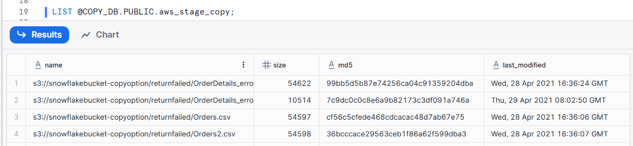

COPY INTO COPY_DB.PUBLIC.ORDERS

FROM @aws_stage_copy

file_format= (type = csv field_delimiter=',' skip_header=1)

pattern='.*Order.*'

ON_ERROR =CONTINUE

RETURN_FAILED_ONLY = TRUE;

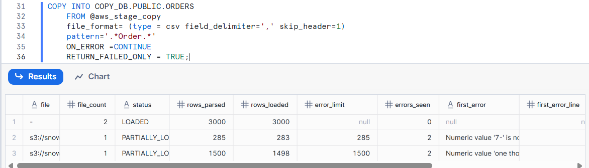

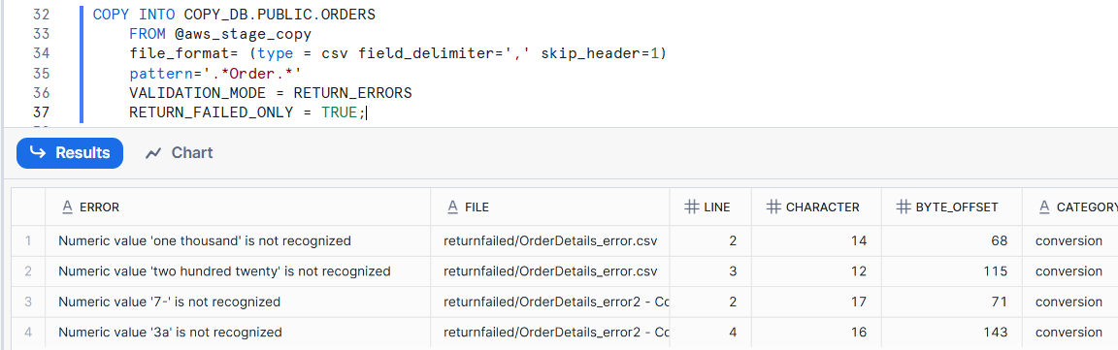

**RETURN_FAILED_ONLY must be used along with either VALIDATION_MODE or ON_ERROR parameters.**

**TRUNACATECOLUMNS:**

Specifies whether to truncate text strings that exceed the target column length.

* **TRUNCATECOLUMNS = TRUE** → The extra characters are **automatically truncated** to fit the column.
* **TRUNCATECOLUMNS = FALSE** (default) → The entire row **fails to load** and is recorded as an error.

**Example:**

//creating a table

CREATE OR REPLACE TABLE COPY_DB.PUBLIC.ORDERS (

ORDER_ID VARCHAR(30),

AMOUNT VARCHAR(30),

PROFIT INT,

QUANTITY INT,

CATEGORY VARCHAR(10),

SUBCATEGORY VARCHAR(30));

// Prepare stage object

CREATE OR REPLACE STAGE COPY_DB.PUBLIC.aws_stage_copy

url='s3://snowflakebucket-copyoption/size/';

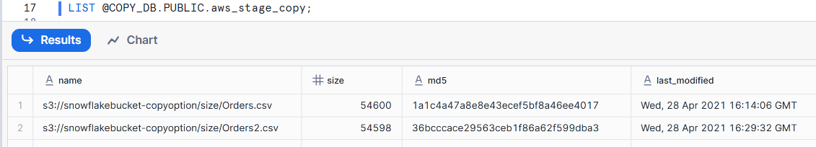

**//Copy command without TRUNCATECOLUMNS option**

COPY INTO COPY_DB.PUBLIC.ORDERS

FROM @aws_stage_copy

file_format= (type = csv field_delimiter=',' skip_header=1)

pattern='.*Order.*';

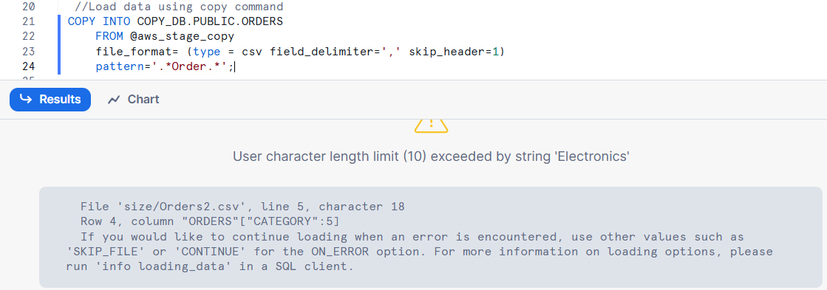

**//Copy command with TRUNCATECOLUMNS option**

COPY INTO COPY_DB.PUBLIC.ORDERS

FROM @aws_stage_copy

file_format= (type = csv field_delimiter=',' skip_header=1)

pattern='.*Order.*'

TRUNCATECOLUMNS = true;

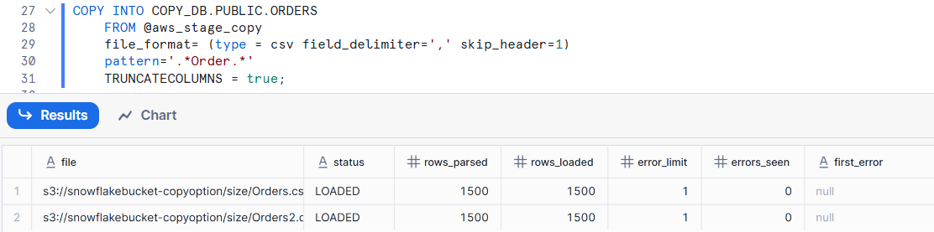

**FORCE:**

Specifies to load all files regardless of whether they have been loaded previously and have not changed since they were loaded.

This option reloads files potentially duplicating data in a table.

**Example:**

//creating a table

CREATE OR REPLACE TABLE COPY_DB.PUBLIC.ORDERS (

ORDER_ID VARCHAR(30),

AMOUNT VARCHAR(30),

PROFIT INT,

QUANTITY INT,

CATEGORY VARCHAR(30),

SUBCATEGORY VARCHAR(30));

// Prepare stage object

CREATE OR REPLACE STAGE COPY_DB.PUBLIC.aws_stage_copy

url='s3://snowflakebucket-copyoption/size/';

//Load data using copy command

COPY INTO COPY_DB.PUBLIC.ORDERS

FROM @aws_stage_copy

file_format= (type = csv field_delimiter=',' skip_header=1)

pattern='.*Order.*';

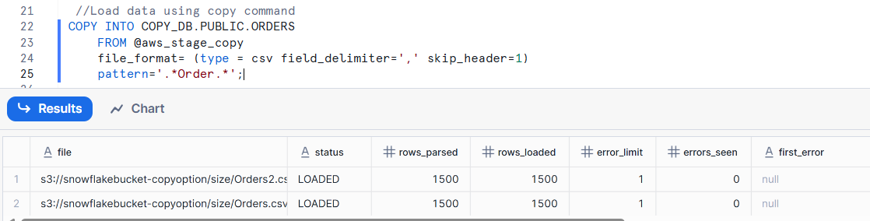

// Not possible to load file that have been loaded and data has not been modified

COPY INTO COPY_DB.PUBLIC.ORDERS

FROM @aws_stage_copy

file_format= (type = csv field_delimiter=',' skip_header=1)

pattern='.*Order.*';

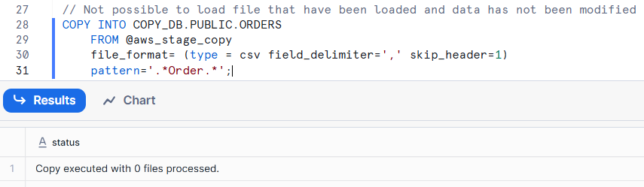

// Using the FORCE option

COPY INTO COPY_DB.PUBLIC.ORDERS

FROM @aws_stage_copy

file_format= (type = csv field_delimiter=',' skip_header=1)

pattern='.*Order.*'

FORCE = TRUE;

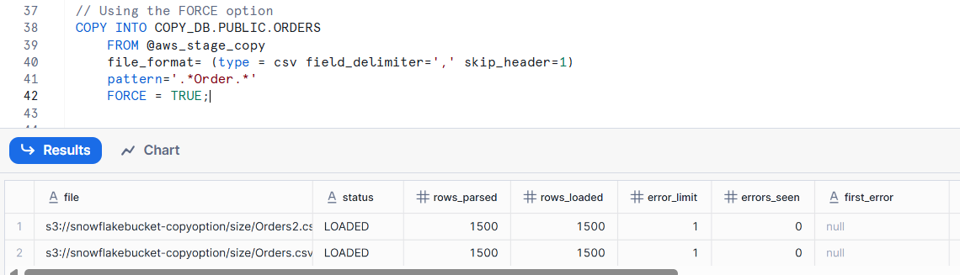

**Load history:**

load history is a record Snowflake maintains to keep track of files that have been loaded using the COPY INTO command.

It’s an important part of how Snowflake prevents duplicate loading of the same file.

**To view load history in existing database**

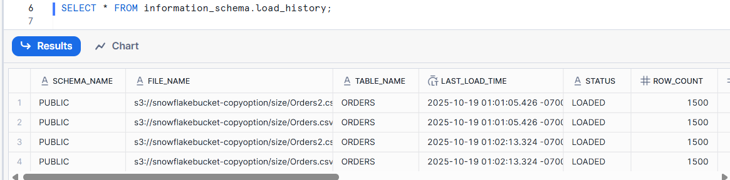

**To view load history in global database**

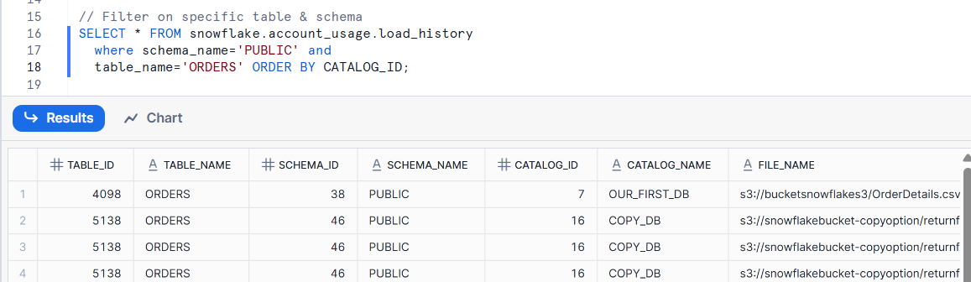

**SEMI STRUCTURED DATA:**

semi-structured data refers to data that does not have a strict tabular format but still contains some organizational structure, such as key–value pairs, arrays, or nested elements.

👉 Common formats include:

* JSON (.json)
* Parquet (.parquet)
* Avro (.avro)
* ORC (.orc)
* XML (.xml)

**Example JSON:**

//creating stage

CREATE OR REPLACE stage FIRST_DB.EXTERNAL_STAGES.JSONSTAGE

url='s3://bucketsnowflake-jsondemo';

//creating JSON file format

CREATE OR REPLACE file format FIRST_DB.FILE_FORMATS.JSONFORMAT

TYPE = JSON;

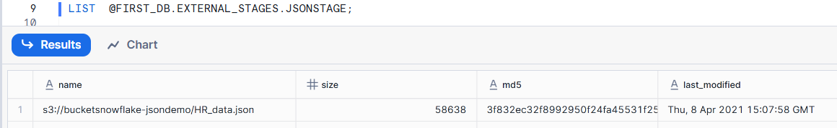

//creating a table to store JSON data

CREATE OR REPLACE table FIRST_DB.PUBLIC.JSON_RAW (

raw_file variant);

//copy command to load JSON data into table

COPY INTO FIRST_DB.PUBLIC.JSON_RAW

FROM @FIRST_DB.EXTERNAL_STAGES.JSONSTAGE

file_format= FIRST_DB.FILE_FORMATS.JSONFORMAT

files = ('HR_data.json');

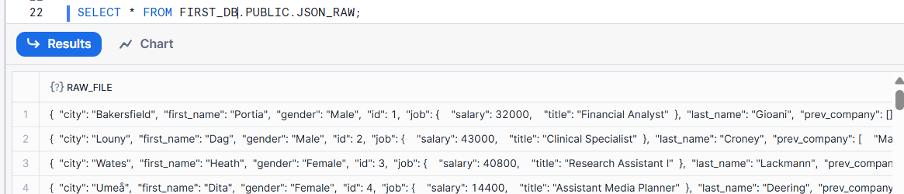

**Record structure:**

{

"city": "Louny",

"first_name": "Dag",

"gender": "Male",

"id": 2,

"job": {

"salary": 43000,

"title": "Clinical Specialist"

},

"last_name": "Croney",

"prev_company": [

"MacGyver, Kessler and Corwin",

"Gerlach, Russel and Moen"

],

"spoken_languages": [

{

"language": "Assamese",

"level": "Basic"

},

{

"language": "Papiamento",

"level": "Expert"

},

{

"language": "Telugu",

"level": "Basic"

}

]

}

**Parse JSON data:**

SELECT

RAW_FILE:first_name::STRING as first_name,

RAW_FILE:job.salary::INT as salary,

RAW_FILE:job.title::STRING as title,

RAW_FILE:spoken_languages[0] as First_language

FROM FIRST_DB.PUBLIC.JSON_RAW;

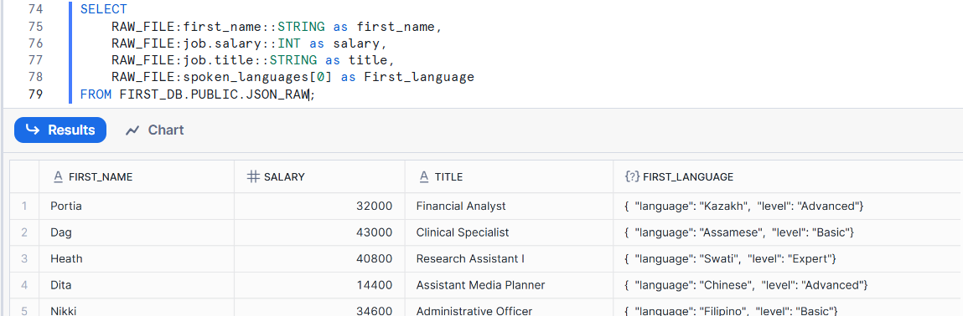

SELECT

RAW_FILE:first_name::STRING as first_name,

array_size(RAW_FILE:spoken_languages) as spoken_languages

FROM FIRST_DB.PUBLIC.JSON_RAW;

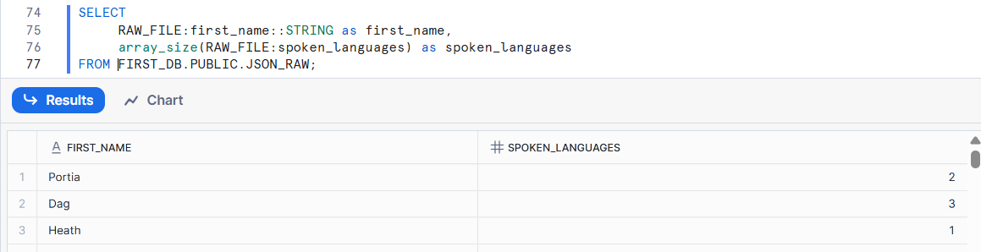

Each person speaks multiple languages so to get all the languages record by record instead of using multiple union queries we can use flatten function.

SELECT

RAW_FILE:id::int as id,

RAW_FILE:first_name::STRING as First_name,

RAW_FILE:spoken_languages[0].language::STRING as First_language,

RAW_FILE:spoken_languages[0].level::STRING as Level_spoken

FROM FIRST_DB.PUBLIC.JSON_RAW

UNION ALL

SELECT

RAW_FILE:id::int as id,

RAW_FILE:first_name::STRING as First_name,

RAW_FILE:spoken_languages[1].language::STRING as First_language,

RAW_FILE:spoken_languages[1].level::STRING as Level_spoken

FROM FIRST_DB.PUBLIC.JSON_RAW

UNION ALL

SELECT

RAW_FILE:id::int as id,

RAW_FILE:first_name::STRING as First_name,

RAW_FILE:spoken_languages[2].language::STRING as First_language,

RAW_FILE:spoken_languages[2].level::STRING as Level_spoken

FROM FIRST_DB.PUBLIC.JSON_RAW

ORDER BY ID;

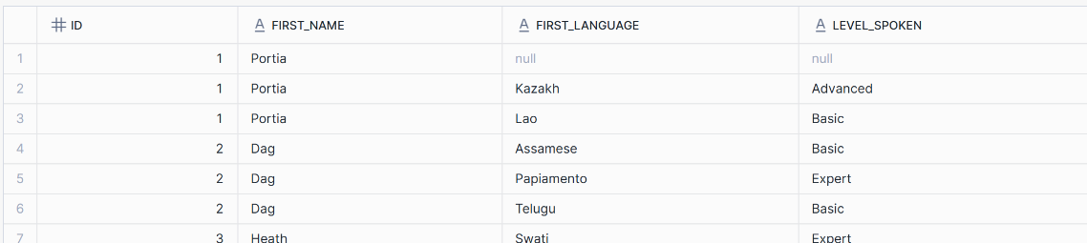

select

RAW_FILE:first_name::STRING as First_name,

f.value:language::STRING as First_language,

f.value:level::STRING as Level_spoken

from FIRST_DB.PUBLIC.JSON_RAW, table(flatten(RAW_FILE:spoken_languages)) f;

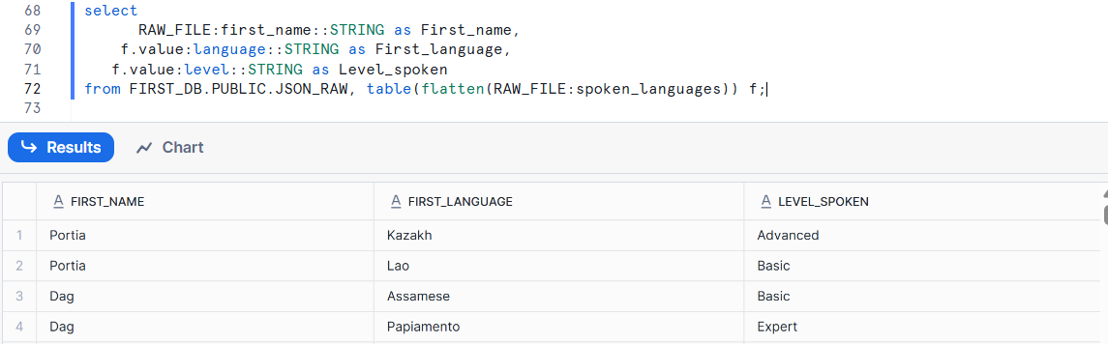

**PARQUET file format:**

CREATE OR REPLACE FILE FORMAT FIRST_DB.FILE_FORMATS.PARQUET_FORMAT

TYPE = 'parquet';

CREATE OR REPLACE STAGE FIRST_DB.EXTERNAL_STAGES.PARQUETSTAGE

url = 's3://snowflakeparquetdemo'

FILE_FORMAT = FIRST_DB.FILE_FORMATS.PARQUET_FORMAT;

// Create destination table

CREATE OR REPLACE TABLE FIRST_DB.PUBLIC.PARQUET_DATA (

ROW_NUMBER int,

index_level int,

cat_id VARCHAR(50),

date date,

dept_id VARCHAR(50),

id VARCHAR(50),

item_id VARCHAR(50),

state_id VARCHAR(50),

store_id VARCHAR(50),

value int,

Load_date timestamp default TO_TIMESTAMP_NTZ(current_timestamp));

// Load the parquet data

COPY INTO FIRST_DB.PUBLIC.PARQUET_DATA

FROM (SELECT

METADATA$FILE_ROW_NUMBER,

$1:__index_level_0__::int,

$1:cat_id::VARCHAR(50),

DATE($1:date::int ),

$1:"dept_id"::VARCHAR(50),

$1:"id"::VARCHAR(50),

$1:"item_id"::VARCHAR(50),

$1:"state_id"::VARCHAR(50),

$1:"store_id"::VARCHAR(50),

$1:"value"::int,

TO_TIMESTAMP_NTZ(current_timestamp)

FROM @FIRST_DB.EXTERNAL_STAGES.PARQUETSTAGE);

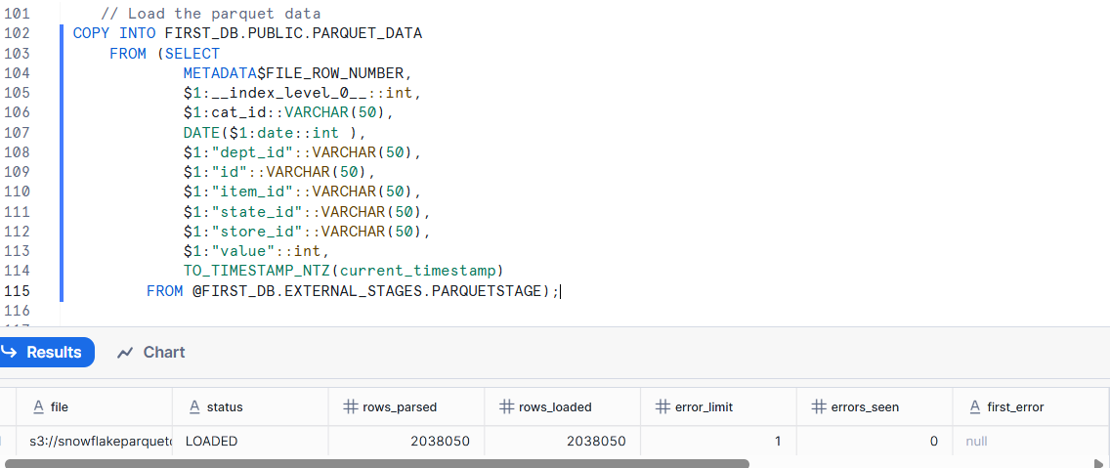

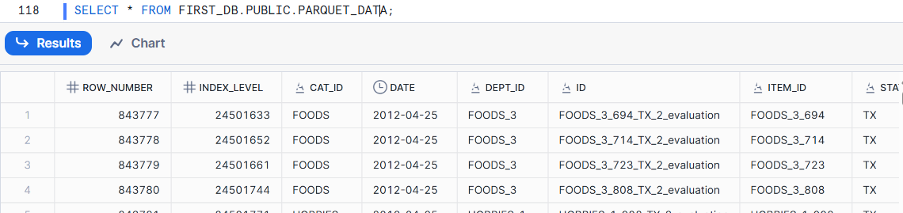

**Storage Integration**

Storage Integration is a secure way to connect Snowflake with external cloud storage such as:

* ☁️ Amazon S3
* ☁️ Microsoft Azure Blob Storage
* ☁️ Google Cloud Storage

It allows Snowflake to access external cloud storage without storing credentials (like access keys or secrets) inside Snowflake.  
This is achieved by setting up a trusted relationship between Snowflake and your cloud provider.

**Step 1: Creating a bucket in GCP.**

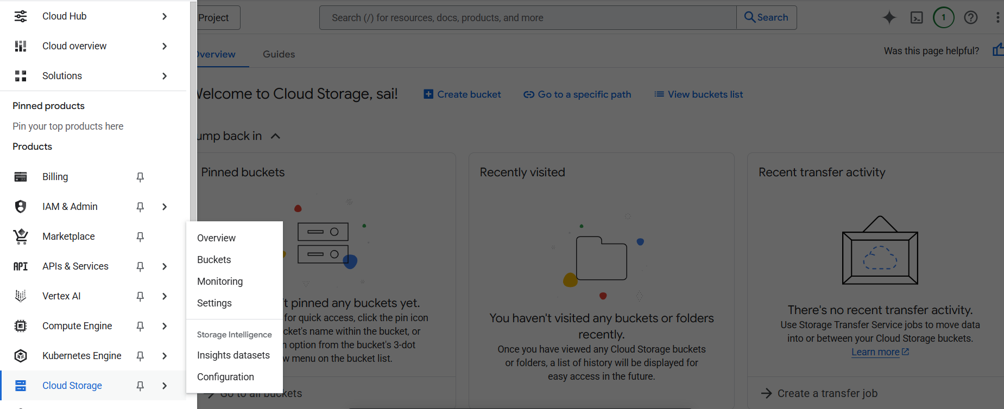

**Click on create bucket**

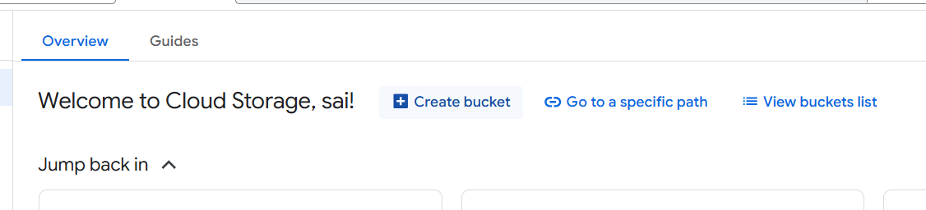

**Give unique bucketname and click continue.**

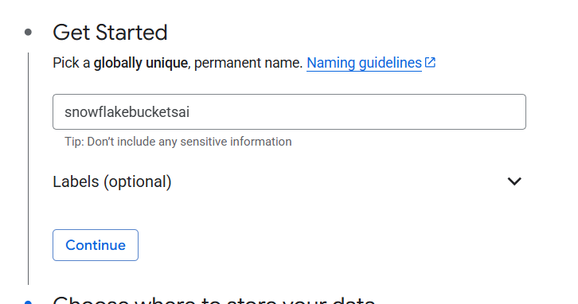

**Select region and click continue.**

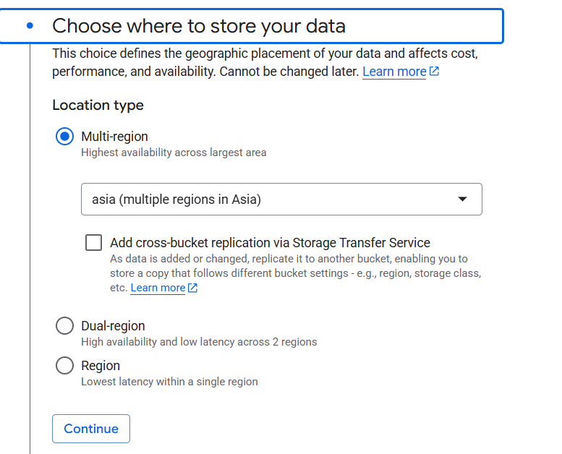

Choose all other options default and click on create.

Created 2 folders in bucket

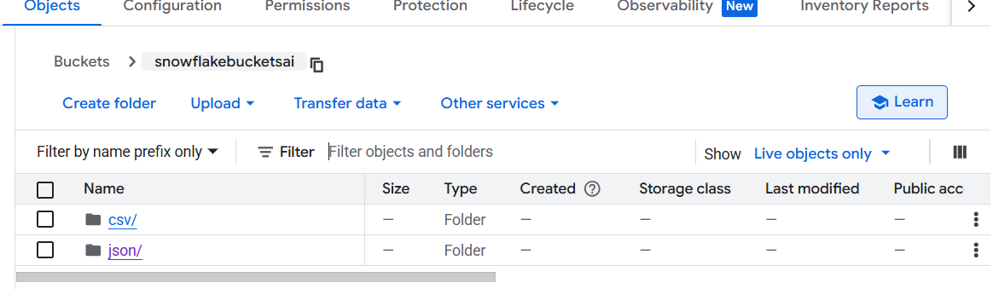

Go to Solutions and search for cloud storage.

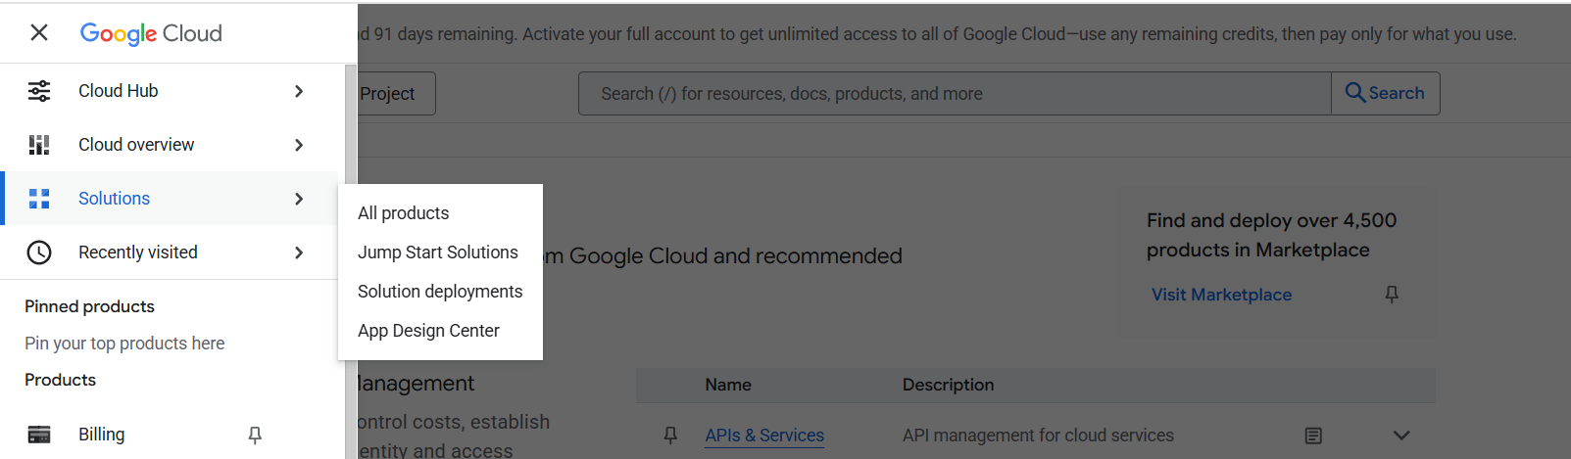

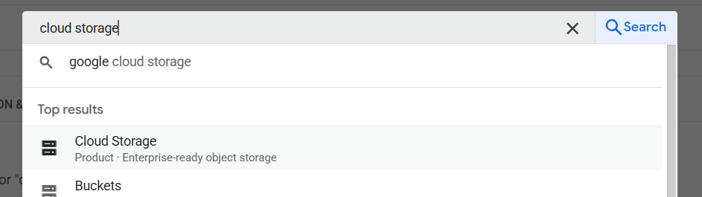

Find your bucket name and give that name in storage integration object in snowflake.

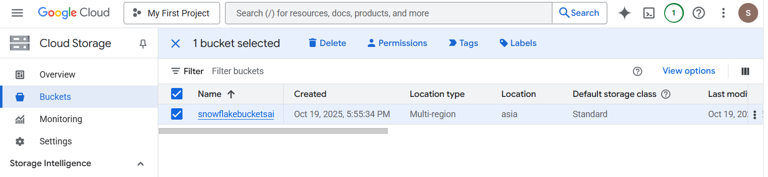

-- create integration object that contains the access information

CREATE STORAGE INTEGRATION gcp_integration

TYPE = EXTERNAL_STAGE

STORAGE_PROVIDER = GCS

ENABLED = TRUE

STORAGE_ALLOWED_LOCATIONS = ('gcs://snowflakebucketsai/csv', 'gcs://snowflakebucketsai/csv');

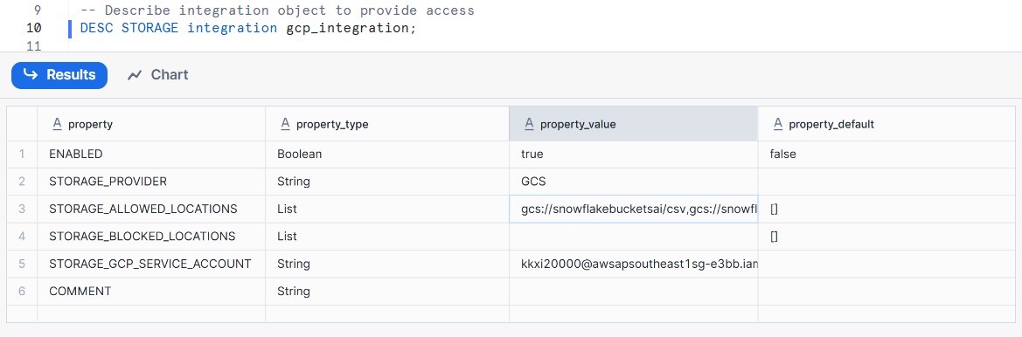

Now copy the STORAGE_GCP_SERVICE_ACCOUNT value.

Select your bucket in GCP and click on permissions.

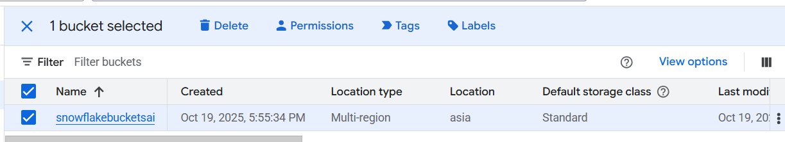

Click on Add principal.

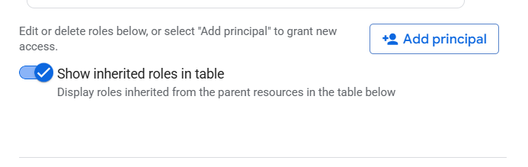

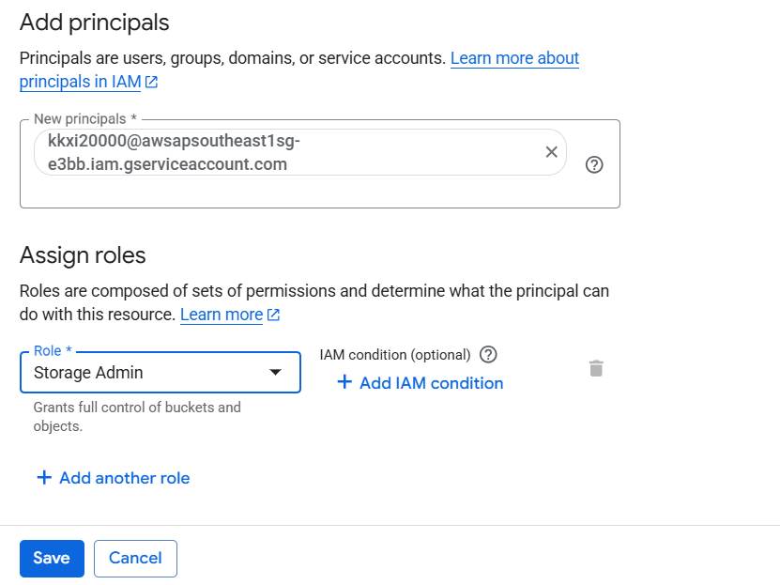

-- create file format

create or replace file format copy_db.public.fileformat_gcp

TYPE = CSV

FIELD_DELIMITER = ','

SKIP_HEADER = 1;

-- create stage object

create or replace stage copy_db.public.stage_gcp

STORAGE_INTEGRATION = gcp_integration

URL = 'gcs://snowflakebucketsai/csv'

FILE_FORMAT = fileformat_gcp;

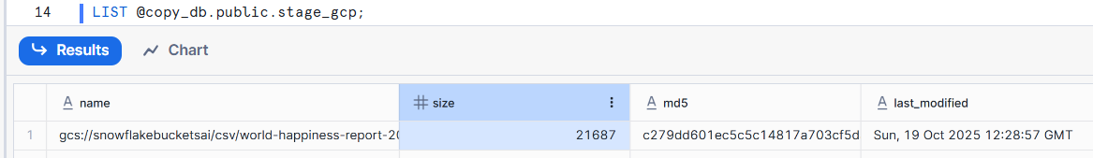

//create a table to load data

create or replace table happiness (

country_name varchar,

regional_indicator varchar,

ladder_score number(4,3),

standard_error number(4,3),

upperwhisker number(4,3),

lowerwhisker number(4,3),

logged_gdp number(5,3),

social_support number(4,3),

healthy_life_expectancy number(5,3),

freedom_to_make_life_choices number(4,3),

generosity number(4,3),

perceptions_of_corruption number(4,3),

ladder_score_in_dystopia number(4,3),

explained_by_log_gpd_per_capita number(4,3),

explained_by_social_support number(4,3),

explained_by_healthy_life_expectancy number(4,3),

explained_by_freedom_to_make_life_choices number(4,3),

explained_by_generosity number(4,3),

explained_by_perceptions_of_corruption number(4,3),

dystopia_residual number (4,3));

//copy command to load data

COPY INTO HAPPINESS

FROM @copy_db.public.stage_gcp;

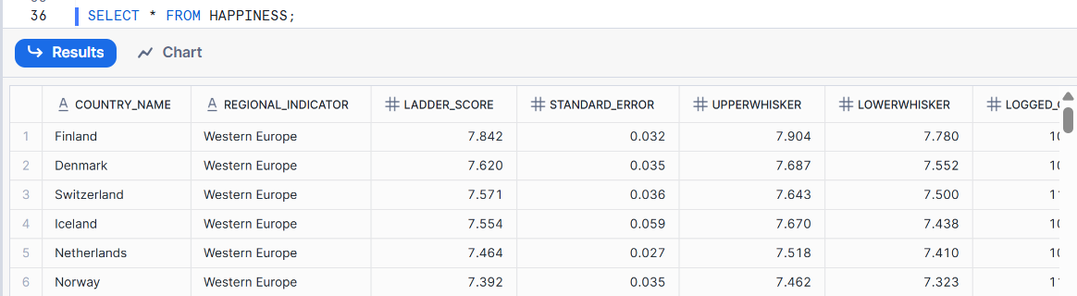

**Unloadind data**

-- create stage object

create or replace stage copy_db.public.stage_gcp

STORAGE_INTEGRATION = gcp_integration

URL = 'gcs://snowflakebucketsai/csv/unload'

FILE_FORMAT = fileformat_gcp;

COPY INTO @stage_gcp

FROM

HAPPINESS;

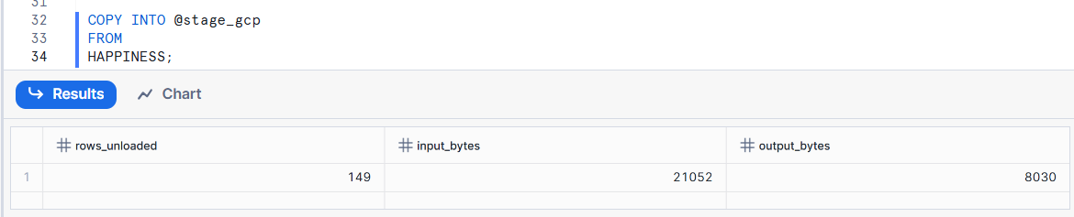

Now one zip file is available in unload path in GCP.

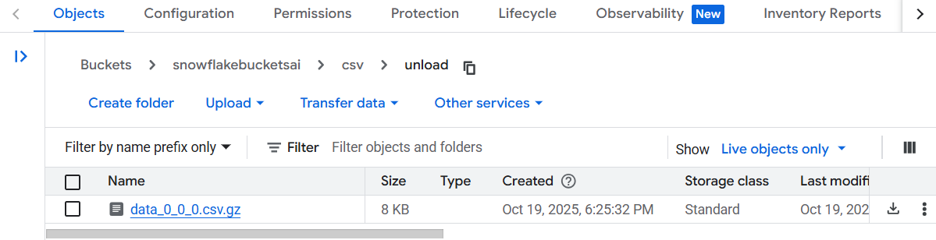

**SnowPipe:**

Snowpipe is Snowflake’s continuous data ingestion service.  
It automatically loads data from files in a stage (internal or external) into a Snowflake table as soon as new files appear — near real-time loading.

| **Feature** | **Description** |
| --- | --- |
| **Continuous Loading** | Automatically loads data without manual intervention. |
| **Serverless** | Fully managed — Snowflake handles compute resources automatically. |
| **Event-Driven** | Can trigger automatically when files arrive in cloud storage (via cloud notifications). |
| **Micro-batching** | Loads data in small batches for low latency and cost efficiency. |
| **Automatic Deduplication** | Prevents reloading of already processed files. |

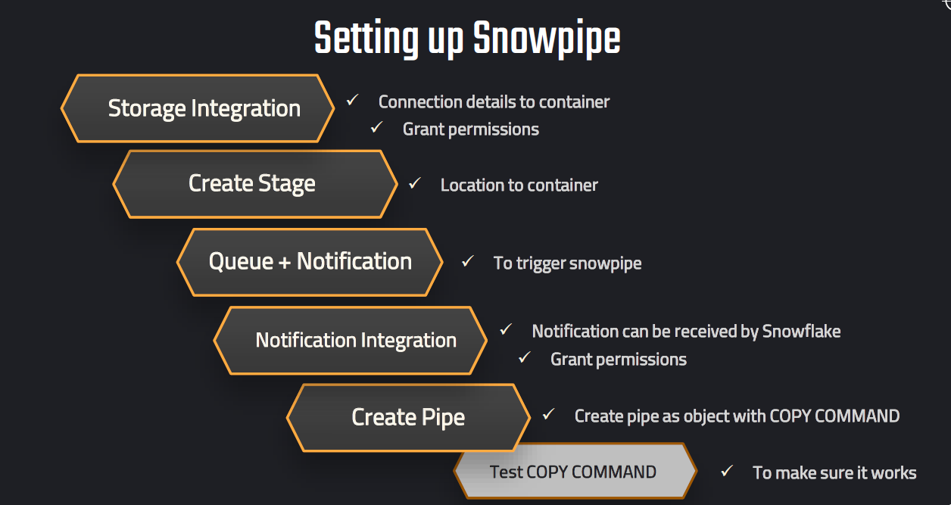

**Example:**

-- create integration object that contains the access information

CREATE OR REPLACE STORAGE INTEGRATION gcp_integration

TYPE = EXTERNAL_STAGE

STORAGE_PROVIDER = GCS

ENABLED = TRUE

STORAGE_ALLOWED_LOCATIONS = ('gcs://snowflakebucketsai/csv', 'gcs://snowflakebucketsai/json');

--create file format

CREATE OR REPLACE file format COPY_DB.file_formats.csv_fileformat

type = csv

field_delimiter = ','

skip_header = 1

null_if = ('NULL','null')

empty_field_as_null = TRUE;

// Create stage object with integration object & file format object

CREATE OR REPLACE stage COPY_DB.external_stages.csv_stage

URL = 'gcs://snowflakebucketsai/csv/snowpipe'

STORAGE_INTEGRATION = gcp_integration

FILE_FORMAT = COPY_DB.file_formats.csv_fileformat;

// Create table first

CREATE OR REPLACE TABLE COPY_DB.PUBLIC.employees (

id INT,

first_name STRING,

last_name STRING,

email STRING,

location STRING,

department STRING

);

CREATE OR REPLACE NOTIFICATION INTEGRATION notification_snowflake

TYPE = QUEUE

NOTIFICATION_PROVIDER = GCP_PUBSUB

ENABLED = TRUE

GCP_PUBSUB_SUBSCRIPTION_NAME = 'projects/amazing-plateau-475612-b3/subscriptions/snowpipe_subscription';

// Define pipe

CREATE OR REPLACE pipe COPY_DB.pipes.employee_pipe

auto_ingest = TRUE

INTEGRATION = notification_snowflake

AS

COPY INTO COPY_DB.PUBLIC.employees

FROM @COPY_DB.external_stages.csv_stage;